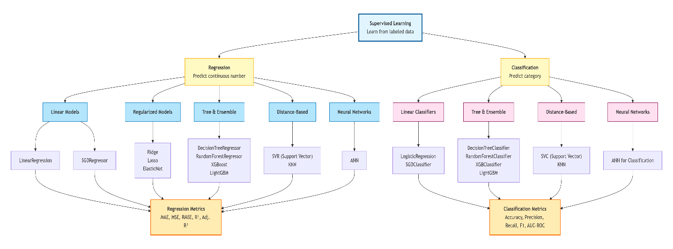
Supervised regression is a type of machine learning where you teach a model to predict a continuous number using labeled data – examples that already have the correct answer.
Let's break that down:
- Supervised means the model learns from data that includes both the inputs (features) and the desired output (label/target). It's like a student learning with an answer key.
- Regression means the output we want to predict is a continuous value (any number, not a category). For example: price, temperature, salary, weight.
So supervised regression = using past examples (with known outcomes) to train a model that can predict a continuous number for new, unseen examples.
Evaluation Metrics for Regression Models
In regression problems, the target variable is continuous—for example, predicting house prices, temperature, or sales. To evaluate how well a regression model performs, we use metrics that measure the difference between actual values and predicted values. These metrics help quantify the model's accuracy and guide us in selecting the best model. Common metrics include Mean Absolute Error (MAE), Mean Squared Error (MSE), Root Mean Squared Error (RMSE), R² Score, and Adjusted R². Each offers a unique perspective on model performance.
- MAE (Mean Absolute Error)
MAE measures the average absolute difference between actual and predicted values.
$$\text{MAE}=\frac{1}{n}\sum_{i=1}^{n}{∣}y_{i}-{\hat{y}}_{i}∣$$
Where:
- $y_{i}$ = actual value
- ${\hat{y}}_{i}$ = predicted value
- $n$ = number of observations
Interpretation:
Lower MAE means better model. MAE = 0 indicates perfect predictions.
Example:
Suppose we have actual house prices (in $1000) and predictions:
Actual | Predicted | Error (Actual - Predicted) | Absolute Error
150 | 140 | 10 | 10
200 | 210 | -10 | 10
250 | 245 | 5 | 5
300 | 310 | -10 | 10
$$\text{MAE}=\frac{10+10+5+10}{4}=\frac{35}{4}=8.75$$
So, on average, the model's predictions are off by $8,750.
Why Absolute Value?
Absolute value prevents positive and negative errors from canceling each other. For example, errors of +10 and -10 would average to 0 without absolute value, which is misleading. With absolute value, we correctly get an average error of 10.
Python Code:
python
from sklearn.metrics import mean_absolute_error

y_true = [150, 200, 250, 300]
y_pred = [140, 210, 245, 310]
mae = mean_absolute_error(y_true, y_pred)
print(mae) # Output: 8.75
- MSE (Mean Squared Error)
MSE measures the average squared difference between actual and predicted values.
$$\text{MSE}=\frac{1}{n}\sum_{i=1}^{n}{(}y_{i}-{\hat{y}}_{i})^{2}$$
Interpretation:
Lower MSE is better. MSE = 0 means perfect predictions. Because errors are squared, large errors are penalized more heavily.
Example:
Using the same data:
Actual | Predicted | Error | Squared Error
150 | 140 | 10 | 100
200 | 210 | -10 | 100
250 | 245 | 5 | 25
300 | 310 | -10 | 100
$$\text{MSE}=\frac{100+100+25+100}{4}=\frac{325}{4}=81.25$$
Why Squaring?
- Removes negative signs.
- Gives a higher penalty to large errors (e.g., an error of 10 contributes 100, while an error of 5 contributes only 25).
Python Code:
python
from sklearn.metrics import mean_squared_error
mse = mean_squared_error(y_true, y_pred)
print(mse) # Output: 81.25
- RMSE (Root Mean Squared Error)
RMSE is the square root of MSE. It brings the error back to the same unit as the target variable.
$$\text{RMSE}=\sqrt{\text{MSE}}=\sqrt{\frac{1}{n}\sum_{i=1}^{n}{(}y_{i}-{\hat{y}}_{i})^{2}}$$
Interpretation:
RMSE is in the same units as the target, making it more interpretable. Lower RMSE is better.
Example:
From the MSE above:
$$\text{RMSE}=\sqrt{81.25}≈9.01$$
So the typical prediction error is about $9,010.
Why RMSE?
MSE is in squared units (e.g., dollars²), which is hard to interpret. RMSE converts it back to dollars (or whatever the original unit is).
Python Code:
python
import numpy as np
rmse = np.sqrt(mean_squared_error(y_true, y_pred))
print(rmse) # Output: 9.013...
- R² Score (Coefficient of Determination)
R² measures how well the model explains the variance in the target variable.
$$R^{2}=1-\frac{SS_{res}}{SS_{tot}}$$
Where:
- $SS_{res}=∑(y_{i}-{\hat{y}}_{i})^{2}$ (sum of squared residuals)
- $SS_{tot}=∑(y_{i}-\overset{ˉ}{y})^{2}$ (total sum of squares, i.e., variance of actual values)
Interpretation:
- R² = 1: Perfect model.
- R² = 0: Model predicts no better than simply using the mean.
- R² < 0: Model is worse than the mean baseline.
Example:
Using the same data, first compute the mean of actual values:
$$\overset{ˉ}{y}=(150+200+250+300)/4=225$$
Now compute $SS_{tot}$ and $SS_{res}$:
Actual | Predicted | Residual (y - ŷ) | Squared Residual | (y - ȳ) | Squared (y - ȳ)
150 | 140 | 10 | 100 | -75 | 5625
200 | 210 | -10 | 100 | -25 | 625
250 | 245 | 5 | 25 | 25 | 625
300 | 310 | -10 | 100 | 75 | 5625
$$SS_{res}=100+100+25+100=325 \\ SS_{tot}=5625+625+625+5625=12500 \\ R^{2}=1-\frac{325}{12500}=1-0.026=0.974$$
So the model explains 97.4% of the variance in house prices.
Python Code:
python
from sklearn.metrics import r2_score
r2 = r2_score(y_true, y_pred)
print(r2) # Output: 0.974
- Adjusted R²
Adjusted R² modifies R² to account for the number of features in the model. It penalizes adding useless features.
$$\text{Adjusted }R^{2}=1-\left(\frac{\left(1-R^{2})(n-1\right)}{n-p-1}\right)$$
Where:
- $n$ = number of observations
- $p$ = number of features
Why needed?
R² always increases or stays the same when you add more features, even if those features are irrelevant. Adjusted R² can decrease if the new features don't improve the model enough.
Example:
Suppose we have two models predicting house prices with the same dataset (n = 100).
- Model A (p = 3 features): R² = 0.85
- Model B (p = 10 features): R² = 0.86
Compute Adjusted R² for each:
For Model A:
$$\text{Adj }R^{2}=1-\frac{\left(1-0.85)(100-1\right)}{100-3-1}=1-\frac{0.15×99}{96}=1-\frac{14.85}{96}≈1-0.1547=0.8453$$
For Model B:
$$\text{Adj }R^{2}=1-\frac{\left(1-0.86)(100-1\right)}{100-10-1}=1-\frac{0.14×99}{89}=1-\frac{13.86}{89}≈1-0.1557=0.8443$$
Even though R² increased from 0.85 to 0.86, Adjusted R² decreased (0.8453 → 0.8443), indicating that the extra features do not provide meaningful improvement.

Summary Table
Metric | Formula | Interpretation | Sensitivity to Outliers
MAE | $$\frac{1}{n}∑∥y_{i}-{\hat{y}}_{i}∥$$ | Average absolute error | Low
MSE | $$\frac{1}{n}∑(y_{i}-{\hat{y}}_{i})^{2}$$ | Average squared error | High
RMSE | $$\sqrt{MSE}$$ | Typical error in original units | High
R² | $$1-\frac{SS_{res}}{SS_{tot}}$$ | Proportion of variance explained | –
Adj. R² | $$1-\frac{\left(1-R^{2})(n-1\right)}{n-p-1}$$ | R² penalized for extra features | –

These metrics help you choose the best regression model for your problem. highest R² and lowest MAE/MSE, making it the best among the models. Always remember to evaluate on a test set (or use cross-validation) to get a reliable estimate of performance.

